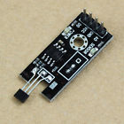**Hall Switch Sensor Module For Arduino Smart Car Motor Speed Test**

**Hall Switch Sensor Module For Arduino Smart Car / Motor Speed Test New**

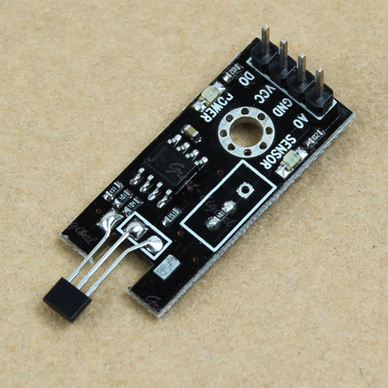

 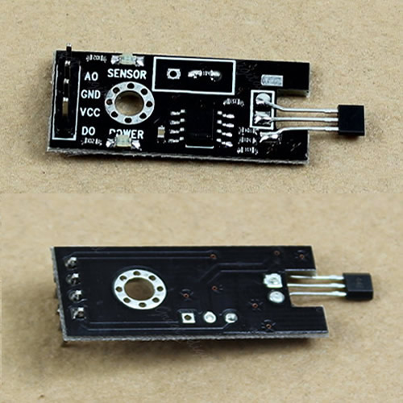 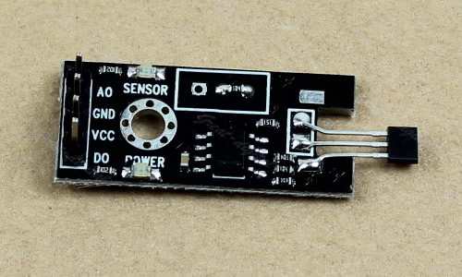

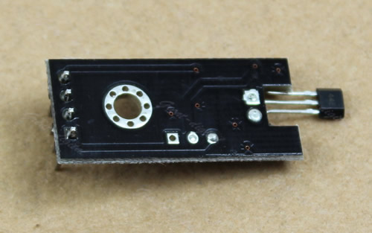

**Description:**

* **100% brand new and high quality.**
* Small Dimension:36mm × 16mm/1.40" x 0.62"(inch) (approx)
* Fixed hole: 3mm/0.12"
* With Power LED, Sensor Indicator LED
* Voltage input range: 3V-24V
* Pin Definition :
* * Pin Definition Note
* * Pin1 AO Sensor Analog Output
* * Pin2 GND Ground
* * Pin3 VCC Power，3V~24V
* * Pin4 DO Digital Output